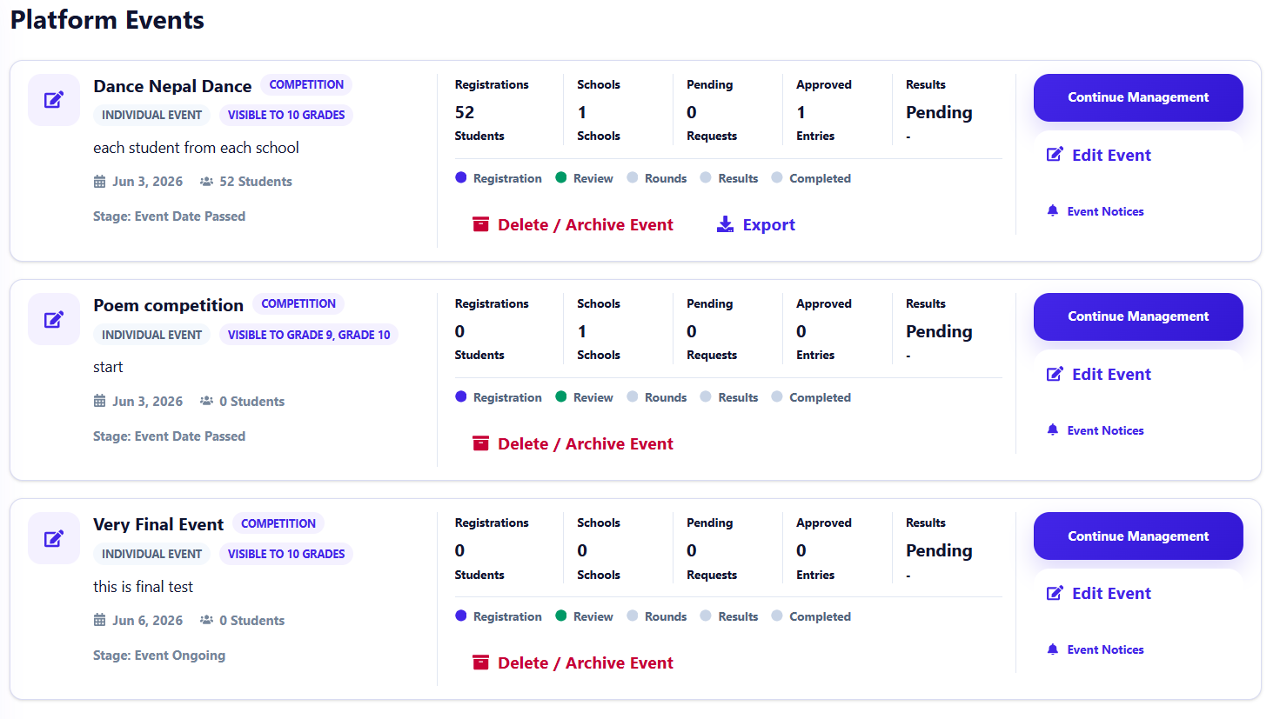during event creating, latest event appear at button, but it should appear at top,
- organized events mean platform control it, platform create rounds and all,
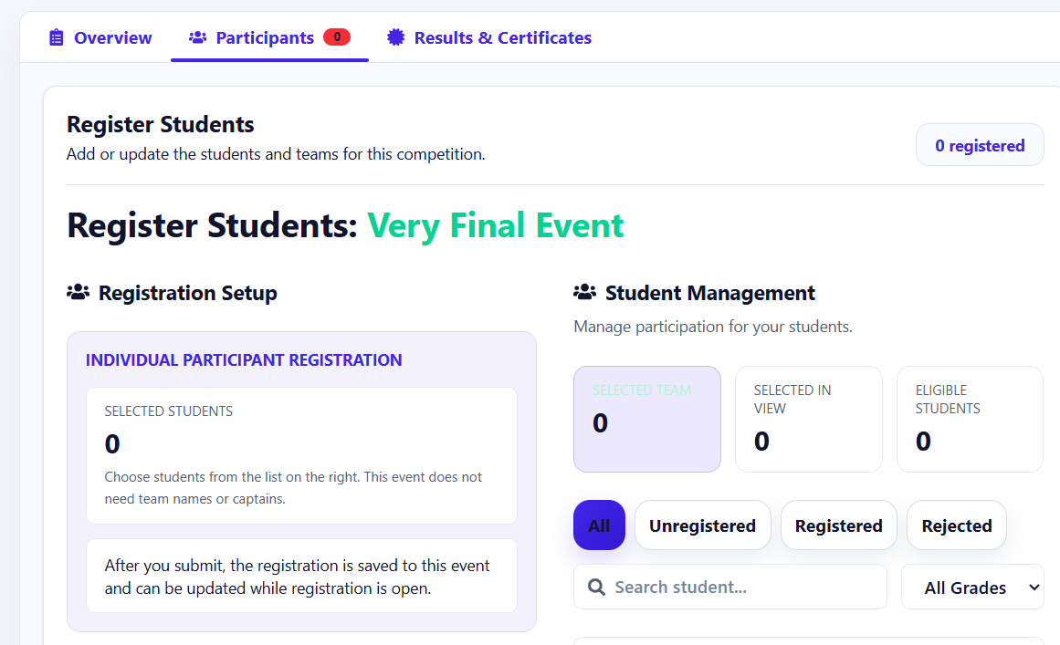but here there is no wound and other options why? How do platform choose winner and all in this way ? analyse,
platform create event and no notification in school , so there is problem in it, fix it, notification sould be instand, without reloading and all, real time,
- okay platform create event and it appear in school dashboard, but as soon as I approve from school it disappear, so need to analyse this as well,
fix notifications, all real time and notifications for new events only, not old, need lots of fix,
here in sidebar instead of school magazine we should name something different because there are other things as well inside here,
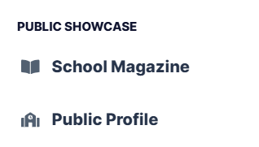
notification for feedback is perfect , take refrence from this, it is real time,
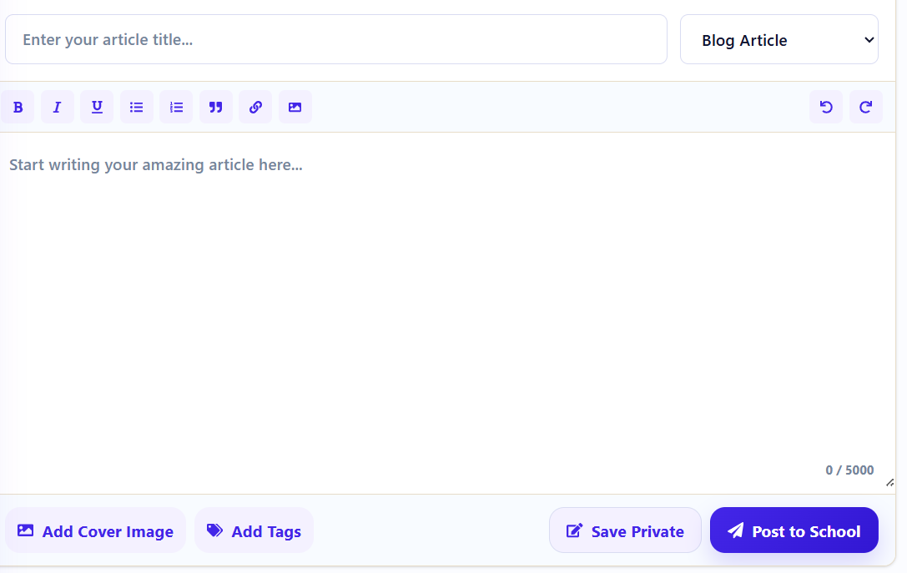
okay here all those button should work like that bold , Itallic and all
- get refrence from school admin event and then do it,
-now this is final change, so, make it mobile friendly ,whole app, tab friendly and small laptop screen friendly as well,
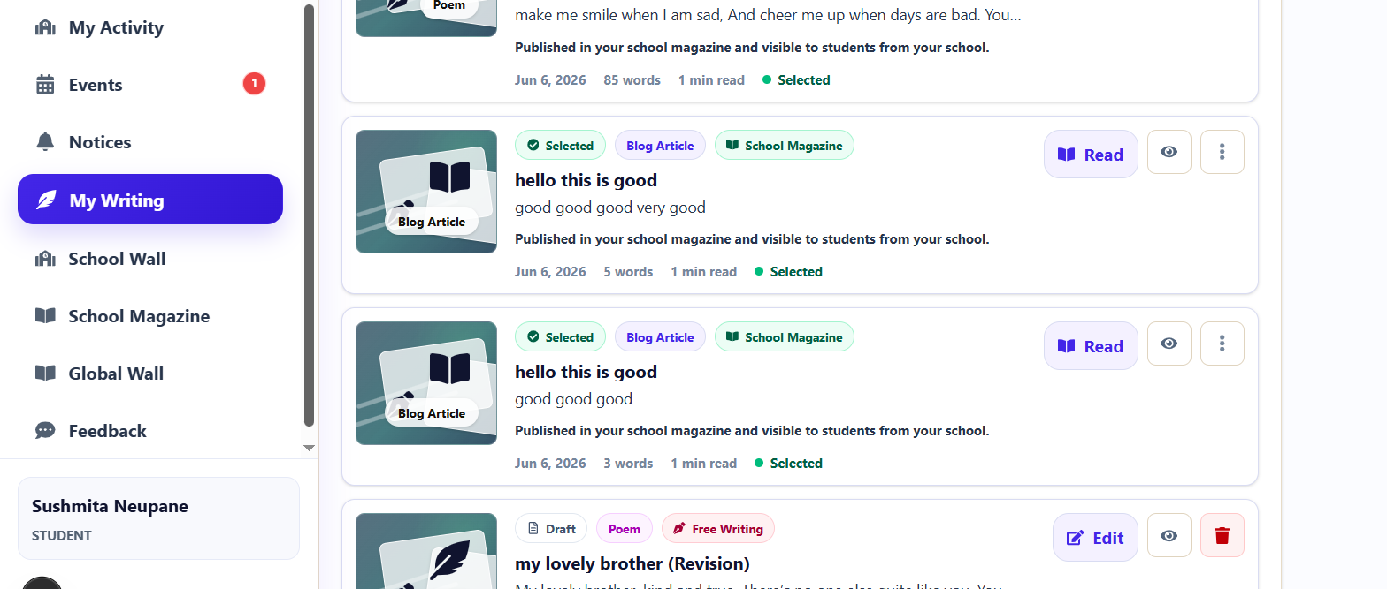
-

- okay here what should happen when I click on 3 dots , cant click right now,


